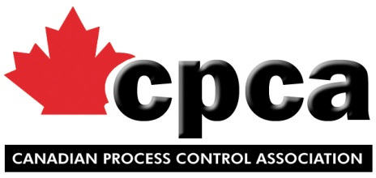
APPLICATION FOR MEMBERSHIP

We wish to apply for membership in the Canadian Process Control Association, and agree to abide by the By-laws thereof.
COMPANY:
Address:
City: |  |  | Province: |  |  |  | Postal Code:
Phone: |  |  | Fax: |  |  |  | Website:

COMPANY REPRESENTATIVE (full name):
Title:
Direct Phone: |  |  |  | Email:

ADDITIONAL REPRESENTATIVE – Controller (full name):
Title:
Direct Phone: |  |  | Email:

ADDITIONAL REPRESENTATIVE - HR (full name):
Title:
Direct Phone: |  |  | Email:

ADDITIONAL REPRESENTATIVE – Regulatory (full name):
Title:
Direct Phone: |  |  | Email:

Annual Sales (Last Fiscal Year – FY): $
Signature
Name: (Print) |  |  |  | Date:
CPCA MEMBERSHIP & DUES STRUCTURE
* All industry members are required to provide monthly statistical reports and the annual product report.
* All new members must be approved by the CPCA Board of Directors.
Note: An initial payment of 50% of the applicable Membership fees will be held as a deposit until such approval is given. Please attach cheque with your application form. Membership applications cannot be submitted to the Board for approval without a deposit.

FULL MEMBERSHIP DUES:
ANNUAL SALES | ANNUAL FEES | HST (13%) | TOTAL FEES
$ 150K – 3 Million | $1,350.00 | $175.50 | $1,525.50
$ 3 – 5 Million | $1,675.00 | $217.75 | $1,892.75
$ 5 – 10 Million | $2,350.00 | $305.50 | $2,655.50
$10 – 20 Million | $2,700.00 | $351.00 | $3,051.00
$20 – 50 Million | $3,350.00 | $435.50 | $3,785.50
$50 – 100 Million | $4,725.00 | $614.25 | $5,339.25
$100+ Million | $6,700.00 | $871.00 | $7,571.00

Please return your completed application form, along with payment to:
Canadian Process Control Association
146 Delarmbro Drive, Erin, ON, N0B 1T0
Phone: (519) 833-7417 / (416) 735-3911
Attn: Trish Torrance
Email: cpca@cpca-assoc.com

